H.T No
Regulations:
A15


Sreenidhi Institute of Science and Technology
(An Autonomous Institution)
Code No: 5A406 Date: 19-Nov-2018 (AN)

B.Tech II-Year II-Semester External Examination, November - 2018 (Supplementary)
Power System – I (EEE)

Time: 3 Hours Max.Marks:75

Note: a) No additional answer sheets will be provided.
b) All sub-parts of a question must be answered at one place only, otherwise it will not be valued.
c) Missing data can be assumed suitably.

Part - A Max.Marks:25

Answer all QUESTIONS.

1. | What is the function of super heater in Thermal power plant? | [3M]
2. | What is the purpose of control rods in nuclear reactor? | [3M]
3. | Define Self GMD and Mutual GMD. | [3M]
4. | How the transmission lines are classified? | [3M]
5. | What are sag templates and stringing chart? | [3M]
6. | What is the purpose of metallic sheath in underground cables? | [2M]
7. | What is mass curve? | [2M]
8. | Define efficiency and voltage regulation of a transmission line. | [2M]
9. | Define skin effect. | [2M]
10. | Give the expression for insulation resistance of a cable. | [2M]
Part – B Max.Marks:50
ANSWER ANY FIVE QUESTIONS. EACH QUESTION CARRIES 10 MARKS.

11. | a) | Explain in detail the classification of hydroelectric plant based on head. | [5M]
 | b) | What are the factors to be considered while selecting the site for a thermal power station? | [5M]
12. | a) | Describe the construction and working of a Pressurized Water Reactor (PWR). What are its advantages and disadvantages? | [5M]
 | b) | List out the advantages and disadvantages of Gas plants. | [5M]
13. | a) | Deduce an expression for the capacitance per phase of a 3-phase line with equilateral spacing. | [5M]
 | b) | Calculate the inductance per phase of a three-phase, double circuit line as shown in Figure. The diameter of each conductor is 1.5m.  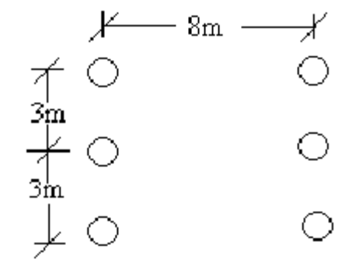 | [5M]
14. | a) | Derive ABCD constants of a medium transmission line using nominal-T representation. | [5M]
 | b) | The following data refers to a 50Hz, three-phase transmission line: length 150km; delivers 50MW at 110KV and 0.8 p.f lagging.  The resistance = 0.1Ω per phase per kilometer,  inductive reactance = 0.5Ω per phase per kilometer and  capacitive shunt admittance = 3x10⁻⁶Ʊ per phase per kilometer.  Determine the sending-end voltage and current using Nominal – Π method. | [5M]
15. |  | A string of 4 insulators is connected across a132kV line. If the capacitance of each disc to earth is 0.1 of the capacitance of the insulator,  calculate  (i) the distribution of voltage on the insulator discs and  (ii) the string efficiency. | [10M]
16. | a) | Explain the construction of an underground cable with a neat diagram. | [5M]
 | b) | A single core, 66kV cable has a conductor diameter of 2cm and a sheath of inside diameter 5.3cm. The cable has an inner layer of 1cm thick of rubber of dielectric constant 4.5 and rest impregnated refer of dielectric constant 3.6. Find the maximum stresses in the rubber and in the paper. | [5M]
17. | a) | What is water hammer effect and explain how it is reduced in hydroelectric power plant? | [5M]
 | b) | What are bundled conductors? Discuss the advantages of bundled conductors when used for overhead lines. | [5M]
18. |  | A three - phase long transmission line has series impedance per phase of 200∟80⁰ Ω and a total shunt admittance of 0.0013∟90⁰ Ʊ per phase. The line delivers a load of 80MW at 0.8 pf lagging and 220kV between the lines. Calculate the sending end voltage, sending end current and sending end power factor . | [10M]

-- 00 -- 00 –

